Criação das rotas

$routeProvider  
 .when(**'/login'**, {  
 **templateUrl**: **'build/views/login.html'**,  
 **controller**:**'LoginController'** })  
  
 .*when*(**'/home'**, {  
 **templateUrl**: **'build/views/home.html'**,  
 **controller**:**'HomeController'** })  
  
 .**when**(**'/clients'**, {  
 **templateUrl**: **'build/views/client/list.html'**,  
 **controller**:**'ClientListController'** })  
  
 .**when**(**'/clients/new'**, {  
 **templateUrl**: **'build/views/client/new.html'**,  
 **controller**:**'ClientNewController'** })  
  
 .**when**(**'/client/:id/edit'**, {  
 **templateUrl**: **'build/views/client/edit.html'**,  
 **controller**: **'ClientEditController'** })  
  
 .**when**(**'/client/:id/remove'**, {  
 **templateUrl**: **'build/views/client/remove.html'**,  
 **controller**: **'ClientRemoveController'** })  
  
 .**when**(**'/project/:id/notes'**, {  
 **templateUrl**: **'build/views/project-note/index.html'**,  
 **controller**: **'ProjectNoteListController'** })  
  
 .**when**(**'/project/:id/notes/:idNote'**, {  
 **templateUrl**: **'build/views/project-note/show.html'**,  
 **controller**: **'ProjectNoteShowController'** })  
  
 .**when**(**'/project/:id/notes/new'**, {  
 **templateUrl**: **'build/views/project-note/new.html'**,  
 **controller**: **'ProjectNoteNewController'** })  
  
 .**when**(**'/project/:id/notes/id:Note/edit'**, {  
 **templateUrl**: **'build/views/project-note/edit.html'**,  
 **controller**: **'ProjectNoteEditController'** })  
  
 .**when**(**'/project/:id/notes/id:Note/remove'**, {  
 **templateUrl**: **'build/views/project-note/remove.html'**,  
 **controller**: **'ProjectNoteRemoveController'** });  
  
 *//Autenticar* OAuthProvider.configure({  
 **baseUrl**: appConfigProvider.config.**baseUrl**,  
 **clientId**: **'appid1'**,  
 **clientSecret**: **'secret'**, *// optional* **grantPath**: **'oauth/access_token'**,  
 });

Criação das do diretório Project-note em views e suas views

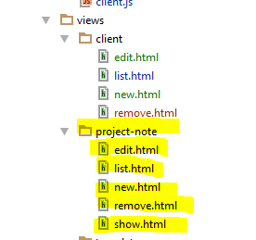

Criação do controollers Project-note e seus controllers

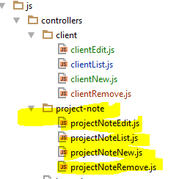

Chamando os Controllers na App;blade

<**script src="**{{ asset(**'build/js/controllers/project-note/projectNoteList.js'**) }}**"**></**script**>  
<**script src="**{{ asset(**'build/js/controllers/project-note/projectNoteNew.js'**) }}**"**></**script**>  
<**script src="**{{ asset(**'build/js/controllers/project-note/projectNoteEdit.js'**) }}**"**></**script**>  
<**script src="**{{ asset(**'build/js/controllers/project-note/projectNoteRemove.js'**) }}**"**></**script**>